Course 3 Benchmark Test – End of Year

1. The area of a figure is 64 square centimeters. Suppose the sides of the figure are doubled. What will be the new area of the similar figure?

2. Triangle MNO is similar to triangle WXY. Which of the following statements is not necessarily true?
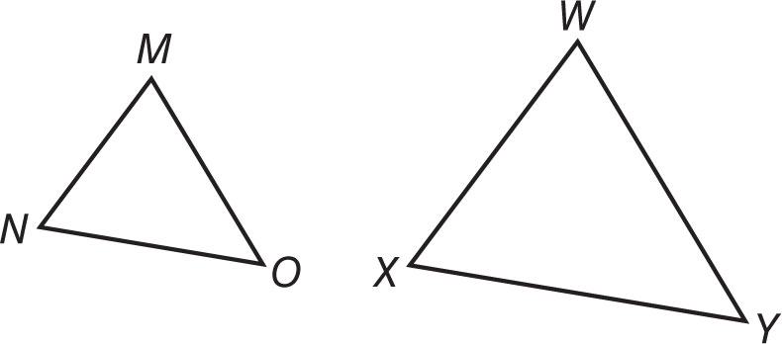

4. A marching band has 64 members. The band director wants to arrange the band members into a square formation. How many band members will be in each row?

5. Between which two integers does $\sqrt{42}$ lie on the number line?

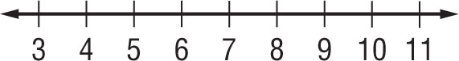

6. What are the slope and y-intercept of the linear equation below?
y = $\frac{2}{3}$ x – 1

Course 3 Benchmark Test – End of Year (continued)

7. What is the equation of the quadratic function shown in the graph?
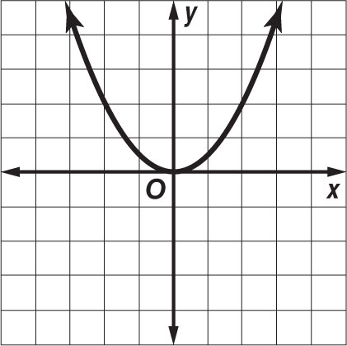

8. What is the volume of a sphere with a radius of 9 inches?
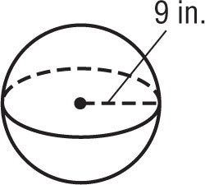

9. What are the x- and y-intercepts of the linear equation below?
–5x + 3y = –15

11. What is the sum of the measures of the interior angles of a hexagon?
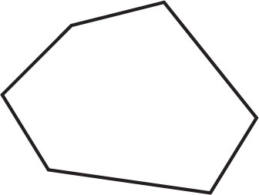

Course 3 Benchmark Test – End of Year (continued)

13. A soup can has a diameter of 8 centimeters and a height of 15 centimeters. About how much soup does the can hold? Use 3.14 for π. Round to the nearest tenth.

15. Parallel lines l and m are intersected by transversal t as shown below. Which of the following angles are alternate interior angles?
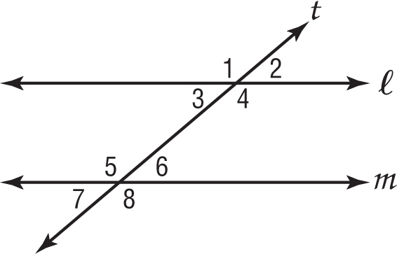

16. What is the distance between points
L(−5, 7) and M(3, −8)?

17. The slope of a line is −3 and the y-intercept is (0, 4). What is the equation of the line in slope-intercept form?

18. What is the value of n in the triangle below?

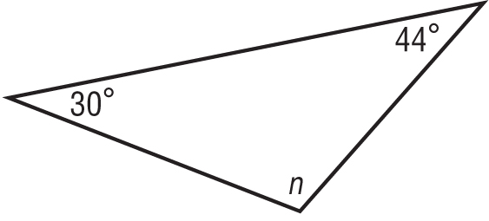

Course 3 Benchmark Test – End of Year (continued)

19. Suppose the dimensions of a rectangular prism are enlarged by a factor of 3. By what scale factor will the volume of the prism be scaled?
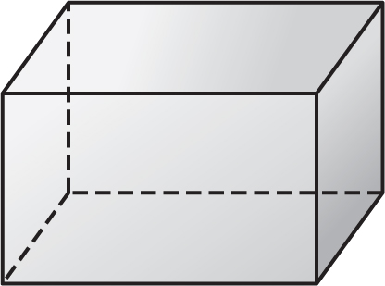

20. What is the measure of an interior angle of a regular octagon?
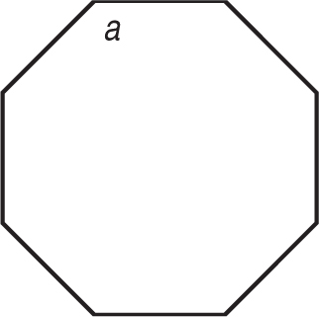

22. Which equation is equivalent to 3x + 2y = –2?

23. Which of the following symbols when placed in the blank results in a true number sentence?

1.7$\overline{3}$______ $\sqrt{3}$

24. What type of relationship is shown in the scatter plot below?

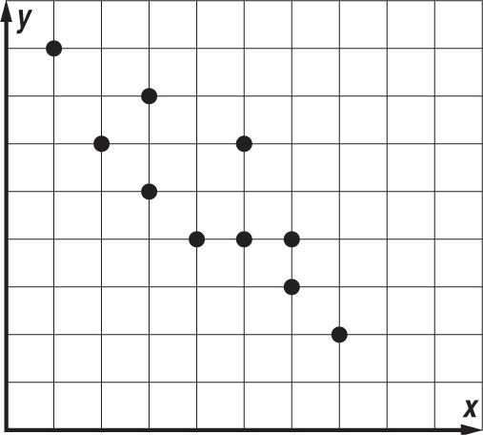

Course 3 Benchmark Test – End of Year (continued)

25. About how much water can the paper drinking cup shown below hold? Use 3.14 for π. Round to the nearest tenth.
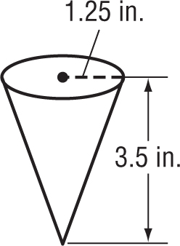

27. Which two points form a line that has a slope of $\frac{5}{2}$?

28. What is the constant rate of change of the function represented in the table below?

x | y
–6 | –7
–3 | –1
0 | 5
3 | 11

30. Which transformations could have been used to map Figure A onto Figure B?
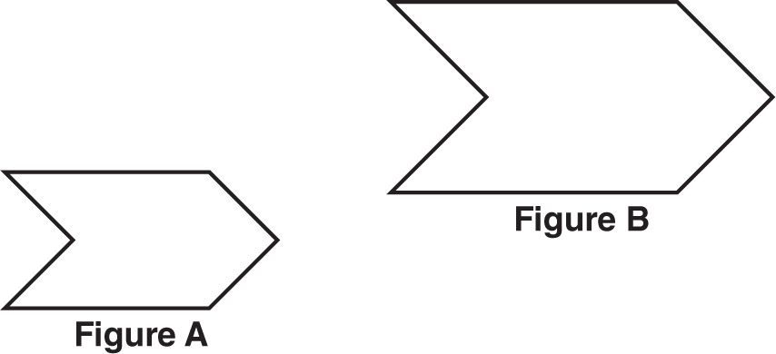

Course 3 Benchmark Test – End of Year (continued)

31. Katie is 5 feet tall. She casts a 3-foot long shadow at the same time that a flagpole casts an 18-foot long shadow.
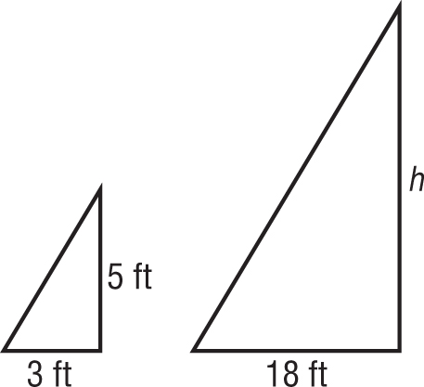

What is the height of the flagpole?

32. What is the approximate surface area of a cylinder with a height of 12 meters and a base radius of
2 meters? Use 3.14 for π. Round to the nearest tenth if necessary.

33. The distance from the Sun to Venus is about
1.08 × 1011 meters. If light travels at a speed of
3 × 108 meters per second, about how long does it take light from the sun to reach Venus?

34. Which of the following is equivalent to 2^{–4}?

35. What is the range of the function shown in the table?
x | –7 | –5 | –3 | –1 | 1
y | 4 | 6 | 1 | –2 | –3

37. A cone has a height of 24 inches, a slant height of
25 inches, and a diameter of 14 inches. What is the surface area of the cone?

Course 3 Benchmark Test – End of Year (continued)

38. A hotel shuttle service charges $7.50 plus $0.85 per mile. A customer hires a shuttle, and the total charge is $12.60. Which equation can be used to determine the number of miles from the hotel to the airport?

40. The population of the United States is about
3.1 × ${10}^{8}$ people. What is this number written in standard form?

41. Which expression is equivalent to the expression below?

c • c • c • c • d • d • c • d • c • c • d

42. What is the solution to the system of linear equations shown below?
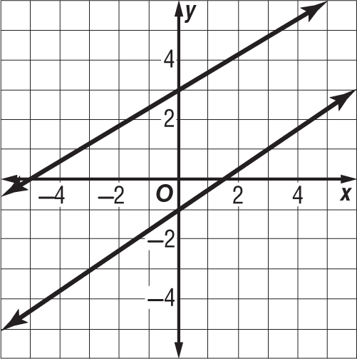

43. Jasmine determines figure ABCD ≅ figure FGHI. If AB = 14 meters, BC = 11 meters, CD = 9 meters, and AD = 17 meters, what is the length of $\overline{GH}$?

Course 3 Benchmark Test – End of Year (continued)

45. What is the slope of the line that passes through points R(0, 2) and T(–3, –4)?

46. Robert has $220 in his savings account. He plans to save an additional $15 each month. Which function can Robert use to determine how much he will have saved s after m months?

47. What type of transformation is represented by the figures below?
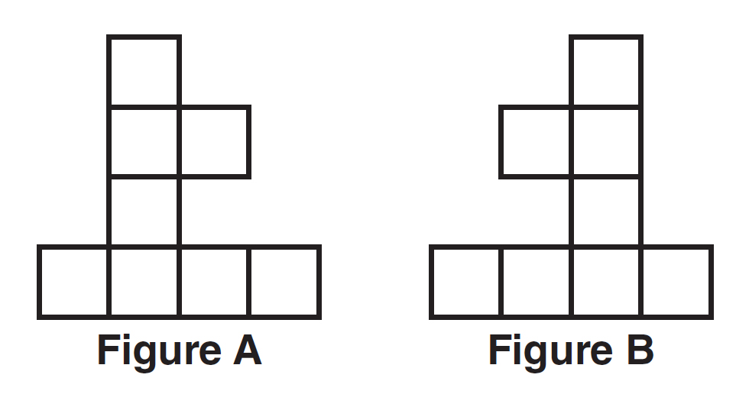

48. Which of the following equations represents a vertical line?

49. Which series of transformations can be used to prove that triangle RST is similar to triangle LMN?
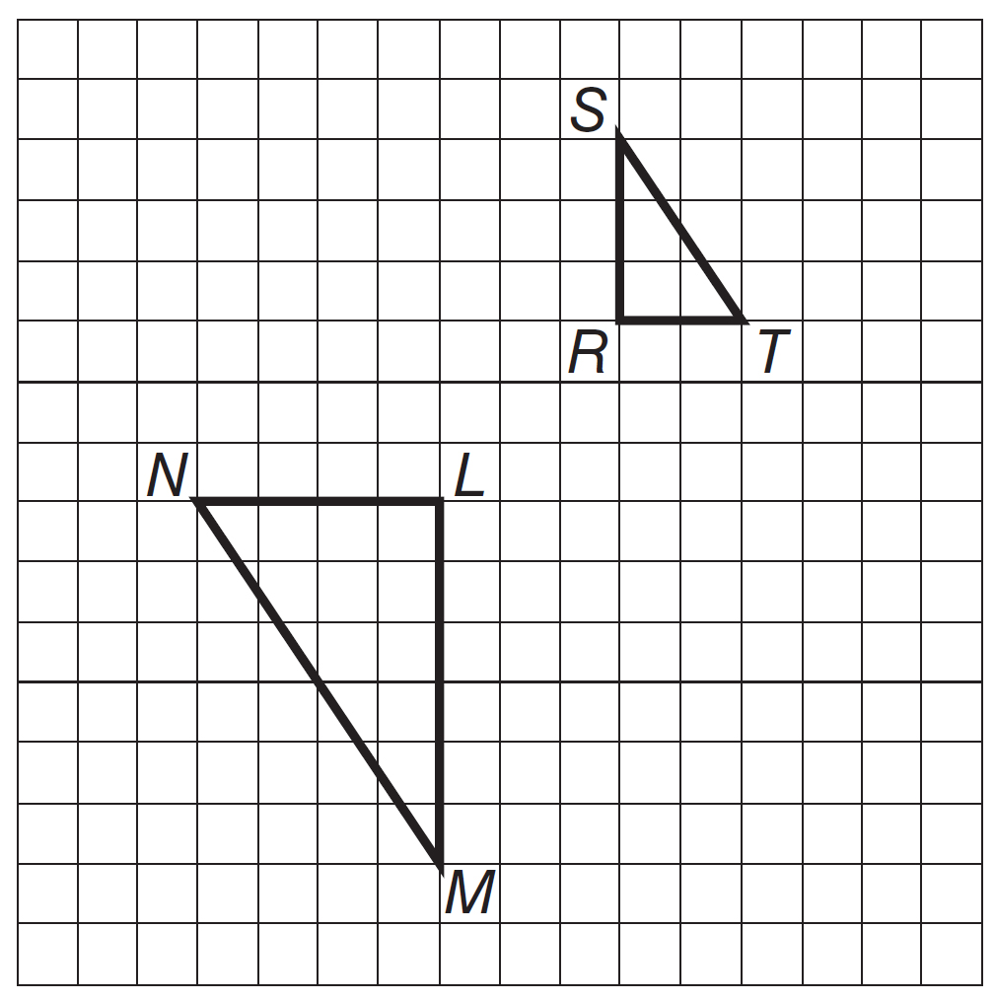

Course 3 Benchmark Test – End of Year (continued)

50. Which of the following statements about a line of best fit is not true?

51. The endpoints of $\overline{AR}$ are A(8, –2) and R(–4, 1). What is the length of $\overline{AR}$? Round to the nearest tenth.

52. What is the value of x in the figure below?
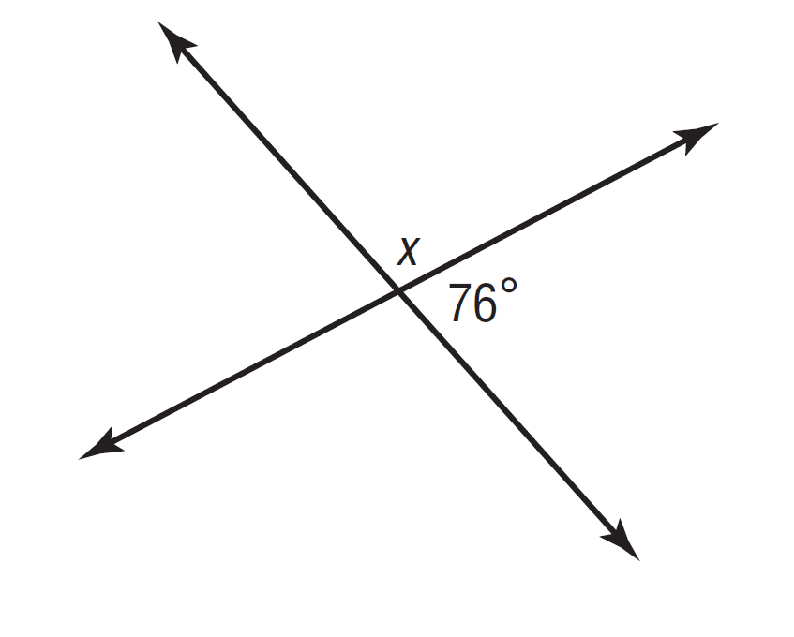

54. Which set lists the values below from least to greatest?

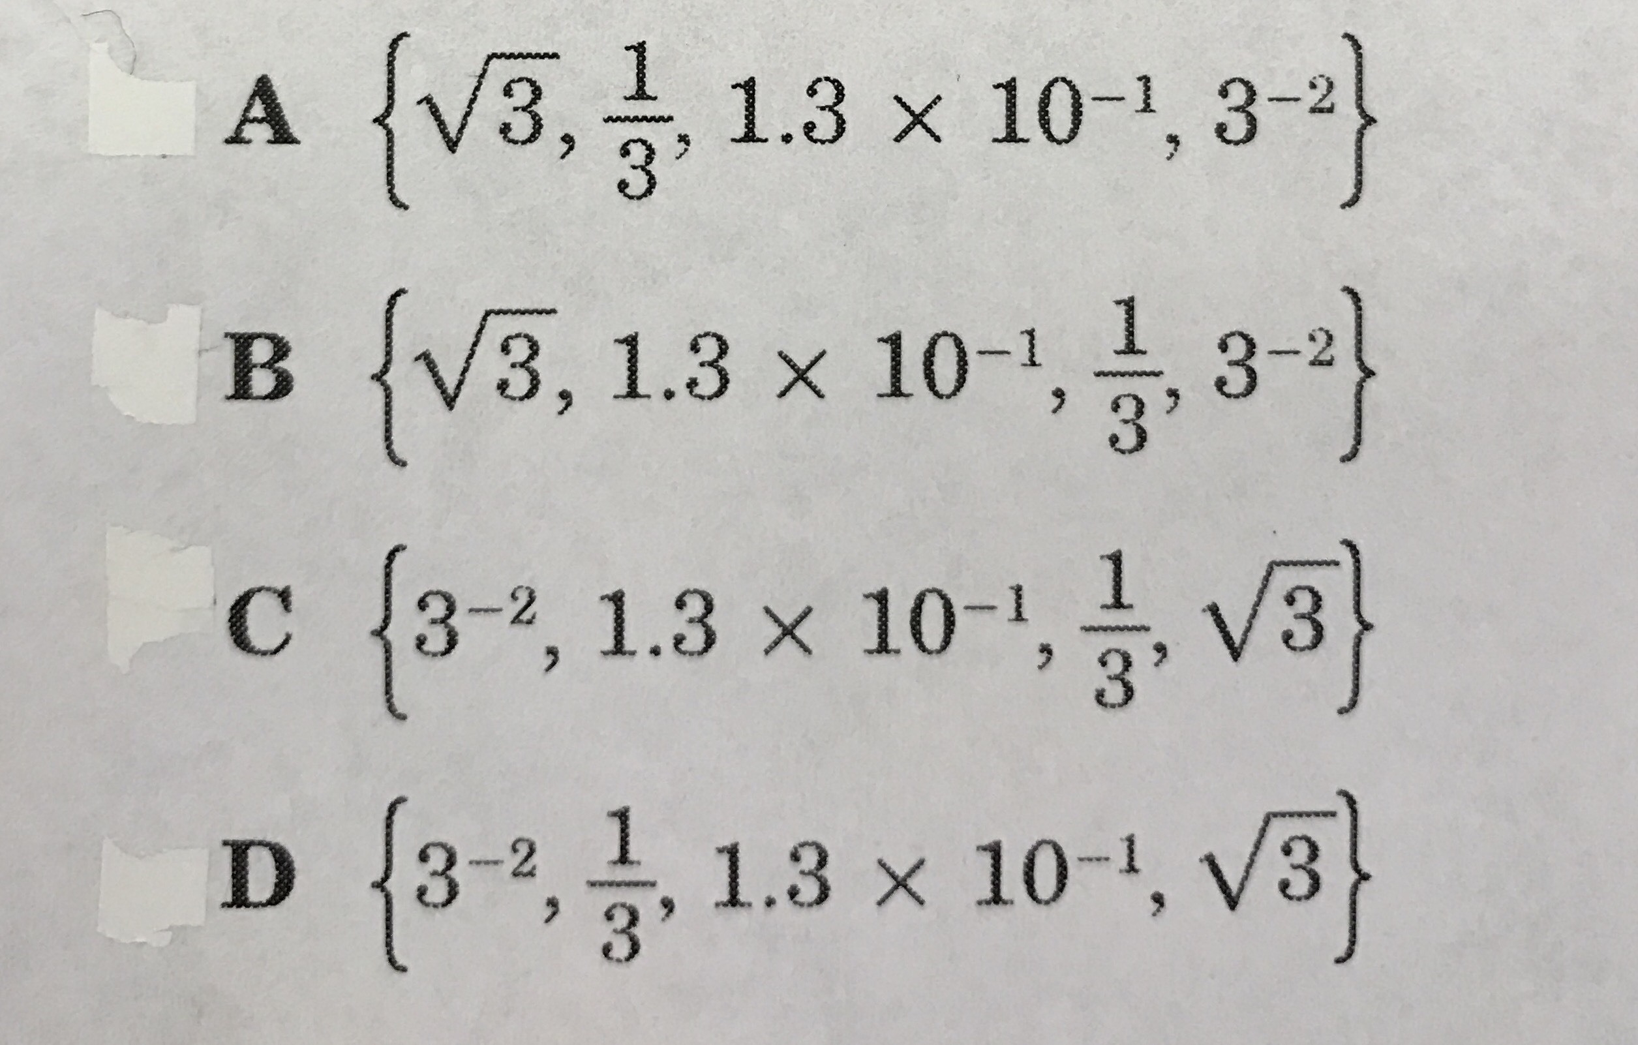
$3^{-2}$, $\sqrt{3}$ , 1.3 × ${10}^{-1}$, $\frac{1}{3}$

56. What is the value of v in the equation below?

3(2v + 1) = -15(5v + 16)

57. What is the solution to the equation below?

0.4p + 0.1 = 1.15

Course 3 Benchmark Test – End of Year (continued)

58. Solve the system of equations below.
7x + 6y = −10
–2x + y = 11

59. The quadratic function h(t) = –16$t^{2}$ + 90 represents the height, in feet, of an object t seconds after it begins falling from a height of 90 feet. What is the height of the object after 2 seconds?

60. Let n represent the figure number in the pattern below.
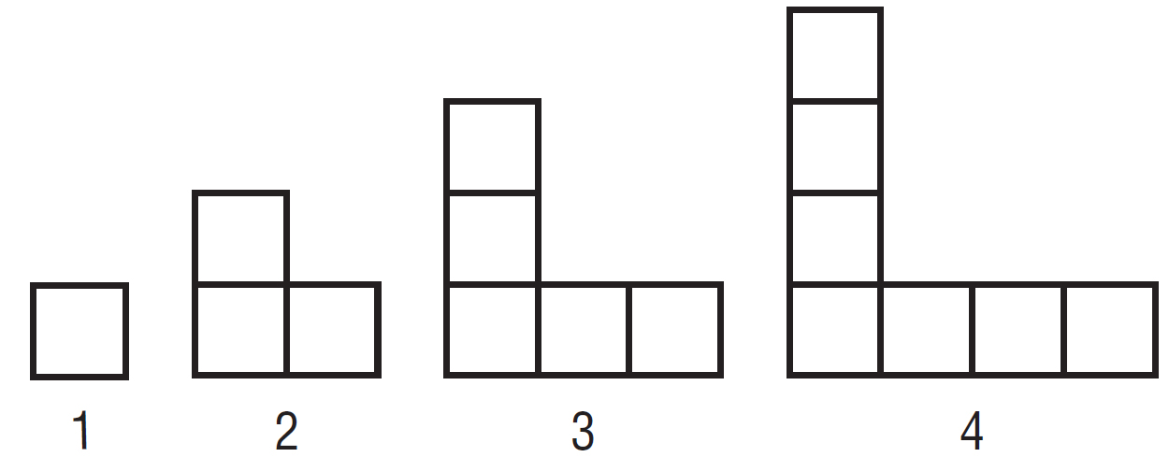

Which function represents the number of squares used to create each figure?

61. By what factor would you need to multiply the dimensions of a polygon in order for the resulting image to have a perimeter that is equal to 4 the original perimeter?

62. A rectangular-shaped school courtyard has a length of 280 feet and a width of 150 feet wide. What is the approximate length of a diagonal of the courtyard to the nearest tenth?

64. What is the scale factor of the dilated figure shown below?
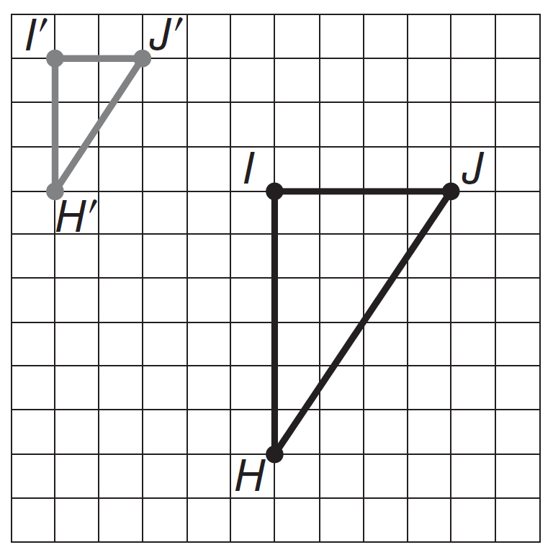

65. Point A(–7, –3) is reflected across the y-axis. What are the coordinates of the image?

